# ABC’s Inventory Management System

## Test Script

|  |  |  |  |  |  |
| --- | --- | --- | --- | --- | --- |
| **Test Name** | | Search Unknown Transfer Then Accept This Transfer (Test Case APT002) | | | |
| **Use Case Tested** | | Accept Product | | | |
| **Test Description** | | This test tests if the system can accept products and its quantity by searching the unknown sending transfer ID. | | | |
| **Pre-Conditions** | | Meta data must exist, product details like product item code, sending location ID and product quantity; transfer details like transfer date, transfer ID, description. | | | |
| **Post-Conditions** | | Appropriate alert message is displayed | | | |
| **Notes** | | This test assumes that the user knows the transferID. | | | |
| **Result (Pass/Fail/Warning/ Incomplete)** | | Pass | | | |
|  | **Test Step** | | **Expected Test Results** | **P** | **F** |
| 1. | Select Accept Product Button from home page | | Display the Accept Product page | P |  |
| 2. | Input incorrect transfer ID in search field and click on the Search Button | | System display an appropriate alert message | P |  |

## Data Set 1

|  |  |
| --- | --- |
| **Test Data Table** | |
| **transferID** | 40 |
| **Destination** | Oxford Store |

# Result Screenshots

The screenshots of the result on each test step for each data set are given below:

**Step 1**

Open the Accept Product Page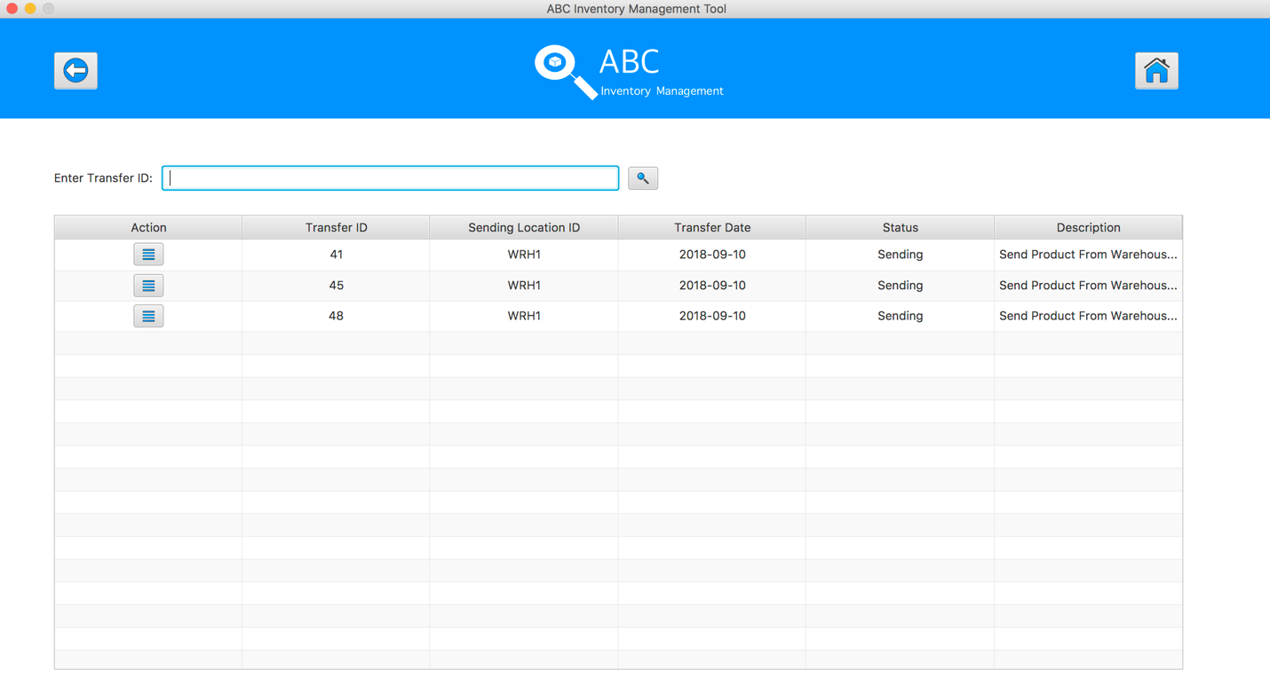

**Step 2**

Input incorrect transfer ID in search field and click on the Search Button. An alert message pops up to notify user entered wrong ID

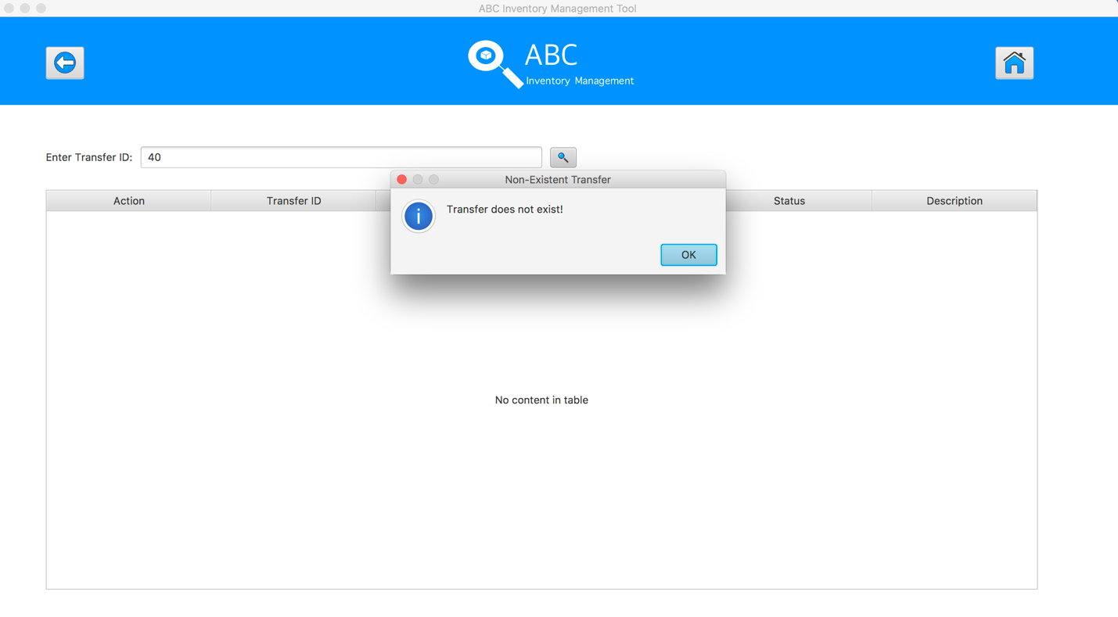

## Data Set 2

|  |  |
| --- | --- |
| **Test Data Table** | |
| **transferID** | ab |
| **Destination** | Oxford Store |

# Result Screenshots

The screenshots of the result on each test step for each data set are given below:

**Step 1**

Open the Accept Product Page

**Step 2**

Input incorrect transfer ID in search field and click on the Search Button. An alert message pops up to notify user entered wrong ID

## Data Set 3

|  |  |
| --- | --- |
| **Test Data Table** | |
| **transferID** | -3 |
| **Destination** | Oxford Store |

# Result Screenshots

The screenshots of the result on each test step for each data set are given below:

**Step 1**

Open the Accept Product Page

**Step 2**

Input incorrect transfer ID in search field and click on the Search Button. An alert message pops up to notify user entered wrong ID

